[](https://evoluzn.in/index.html)

RUNNING LIGHT DATA PATTERN

Protocol: MQTT

Every One-Minute Data from Device Data Pattern:

* Device_id:deviceID:Intensity:device_status:Power:Temperature:Autobrightness:AutoMotion:Lux

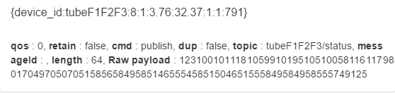

Response on 200:

* device_id:300:Intensity:device_status:Power:Temperature:Autobrightness:AutoMotion:Lux

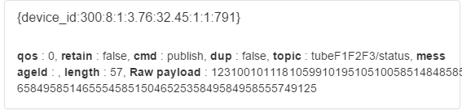

To Update the Intensity:

* Send data in below Format,
* autoBrightness:0:Intensity

Ex. autoBrightness:0:10

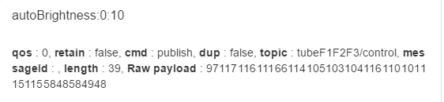

To set the AutoBrightness:

* Send data in below Format,
* autoBrightness:1:Lux

[](https://evoluzn.in/index.html)

Ex. autoBrightness:1:600

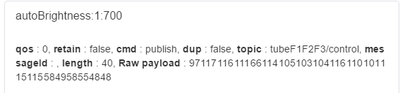

To set the Threshold Temperature:

* Send data in below Format,
* tempOverThreshold:temperature
* Exa: tempOverThreshold:70
* Note: Default set value is 80.
* Once the threshold is updated you will get the response on MQTT for conformation as below,

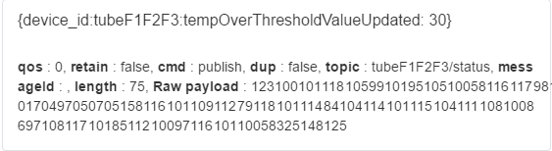

To Set the Maximum Analog Value:

* Send Data in the below Format,
* maxAnalogPulseDutyCycle:Value
* Exa: maxAnalogPulseDutyCycle:250
* Note: Default set value is 204 o Once the threshold is updated you will get the response on MQTT for conformation as below,

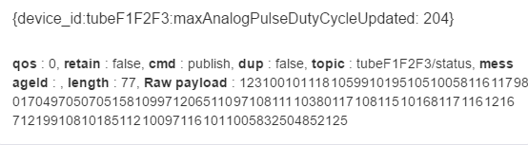

To update Global Topic:

* Send Data in the below Format,
* updateMqttTopic:globalTopic:topic
* Note: The default set topic is evoluznGlobal, and this topic's maximum string length can be 20.
* Once the threshold is updated you will get the response on MQTT for conformation as below,

[](https://evoluzn.in/index.html)

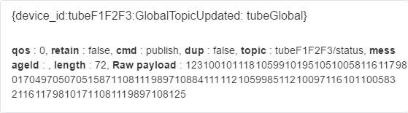

To check the Stored Data:

* Send Data in the below Format,
* storeStatus
* This command checks all internal EEPROM parameters stored in the device,
* Format is,
* {device_id:deviceID:GLOBAL TOPIC:TEMPERATURE THRESHOLD:MAX ANALOG VALUE:MOTION COUNTER:PIR SENSOR DATA:USER DEFINED LUX}

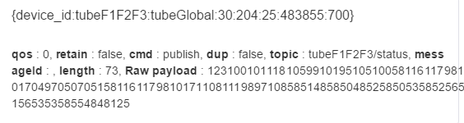

To restart the Device:

* Send the Data in below Format:
* Restart

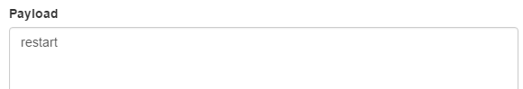

Over Temperature Alerts will publish Every One Minute interval if temperature is above Threshold temperature:

[](https://evoluzn.in/index.html)

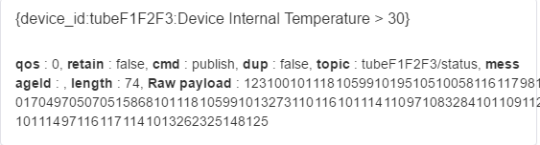

To update the Motion Counter:

* Send data in below Format:
* motionCounter:value

Ex. motionCounter:50

* Note: Default set value is 25.
* Once the counter is updated you will get the response on MQTT for conformation as below,

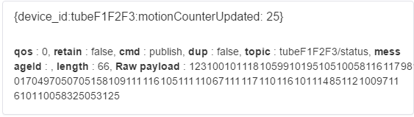

To set the autoMotion ON:

* Send data in below Format:
* autoMotionDetection:100
* Once the auto motion ON you will get the response on MQTT for conformation as below,

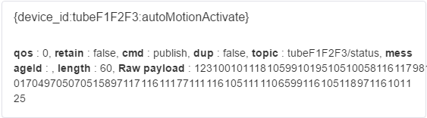

To set the autoMotion OFF:

* Send data in below Format:
* autoMotionDetection:0
* Once the auto motion OFF you will get the response on MQTT for conformation as below,

